**Fair Guessing Chain**

A soCIAL PAN-ENTERTAINMENT GUESS PALTFORM BASED ON BLOCKCHIAIN

V2.0

**Contents**

Chapter 1 Project Background 1

1.1 History Background 1

1.2 Industry Background 2

1.3 Blockchain Background 3

1.4 Token Coin Background 4

Chapter 2 Fair guessing chain Platform Introduction 6

2.1 Product Introduction 6

2.1.1 Description of Fair guessing chain Platform 6

2.1.2 Fair guessing chain Concept 8

2.1.3 Double-chain System of Fair guessing chain 10

2.2 The Significance of the Fair guessing chain Platform 13

2.2.1 Social Significance of the Fair guessing chain 13

2.2.2 Economic Benefit of the Blockchain Guess 15

2.2.3 Application of New Technologies such as AI and Big Data 16

Chapter 3 Introduction of Function Module 17

3.1 Fair guessing chain Basic Technical Framework 17

3.2 Key Techniques of Fair guessing chain 19

3.3 Platform Participants 22

3.3.1 Sponsor of the Project 23

3.3.2 Guess Part of the Project 25

3.3.3 Project Verifier 26

3.4 The Public Service System of the Fair guessing chain 26

3.4.1 Network Platform Service 27

3.4.2 The Access of Third Party Access 27

3.4.3 General management of guess program 27

3.4.4 Cooperation of Online and Offline 28

3.4.5 Asset Exchange 28

3.5 System Module 29

3.5.1 Management System of Fair guessing chain Account 29

3.5.2 Management System of Guess Data 32

3.5.3 Fair guessing chain Intelligent Contract Engine 33

3.5.4 Random Number Generation System of Fair guessing chain 34

3.5.5 Decentralized Information Communication Tool 38

3.5.6 Other Auxiliary Tools of Fair guessing chain 39

Chapter 4 Expansibility 41

4.1 Oracle 41

4.2 Future Extendibility of the Ethereum Technology 43

4.3 Application Context 44

4.4 Cross Chain Purse 46

Chapter 5 Token Mechanism and Issue Program 47

5.1 Double Token Economic Model of Fair guessing chain 47

5.2 FGE Token 47

5.3 FGC Token 49

5.4 Issue Program of FGE Token 50

5.5 FGE Token Distribution Program 50

5.6 FGE Token Sales Program 52

Chapter 6 Fair guessing chain Core Founding Team and Consultants 53

6.1 Fair guessing chain Core Founding Team 53

6.2 Consultants 57

6.3 Early Investor 58

Chapter 7 Fair guessing chain Implementation Road Map 59

# 

# Chapter 1

# Project Background

## History Background

The “blockchain” has become the most popular concept nowadays. Traditional internet solves the transmission of information but cannot solve the problem of “Transitive Trust” at low cost. The multi-center, intermediary, self-organizing, data-sharing trusted network can be formed through the remold of the application of block chain and the block chain of traditional industries. Blockchain technology will drive the world migrate to the value of the Internet from the information Internet. Digitize the asset, break the industry barriers, release the liquidity of the real economy, promote the development of the economy through the excavation of the value of the real economy.

Guess is a daily entertainment pastime of human, initially using for the fair lottery draw, and finally gradually evolving into an industry of game guess, two-person game, welfare lottery, entertainment financing and so on. Fair guessing chain is a Fair guessing service platform serving for the Guess scene, taking the guess scene of the modern society as the pointcut, including sports guess, game guess, lottery draw and so on, using block chain technology to serve the fair guess, public guess, which designed to solve the dispute issues of information easy to tamper, the middle channel is not credible dispute issues in the process of the traditional guessing scenes, increasing circulation efficiency, reducing transaction costs, protecting customer interests.

## Industry Background

Guess industry involves a wide range of areas, including traditional lottery, sports guess, game guess, also including legal gaming and entertainment market in some countries. According to statistics, the global guess industry market size reached 536 billion U.S. dollars (some countries include gaming and entertainment market). As the third region of the global population, the development of the gaming industry of the Southeast Asian countries has been an important industry. The Philippines is the largest gaming scale in Southeast Asia. And the 2018 Philippine market’s total gaming revenues are expected to grow by 9.4%, including online gaming, internet lottery and other emerging internet gaming segments, which play a key role in the country’s gaming industry. Gaming will be an mainly application scene of guessing chain, which will be building a full range of deep cooperative relations with the Philippines, Cambodia and other Southeast Asian countries gambling entertainment companies, to provide a new guess services.

## Blockchain Background

The block chain is essentially a decentralized distributed ledger database, whose value is to generate a series of data blocks by constructing self-organizing networks and using cryptographic correlation algorithm. Each of data blocks contain the information of valid confirmation of multiple trades. And the time is orderly and cannot be tampered. Thus, a distributed consensus mechanism is established to realize the decentralized trust system. For example, Bitcoin, the underlying architecture technology is block chain technology, using the features of decentralized, unforgeable, open and transparent, distributed accounting, tamper-proofing, intelligent contract and so on, realizing that transferring the value to the world without intermediary.

At the same time, as a kind of database, blockchain has several major characteristics. First, records can only be added to this database, and cannot be removed or changed. Second, the blockchain database is distributed across multiple computers, which have a partial or complete copy of the database. For example, the Bitcoin blockchain is stored on millions of machines. In addition, there is an important feature that we can deploy computer code to the blockchain for permanent storage and wait to be executed. Therefore, the blockchain has the feature of immutability, coupled with its distribution on multiple computers, which means that hackers are extremely difficult to tamper it

## Token Coin Background

The token coin is also called the digital currency, the virtual currency, which is a kind of cryptocurrency issued by non-bank, fiduciary institutions, electronic currency organizations. Cryptocurrency is a monetary system, which its value is not embodied in material and physical use, but in the degree of the public recognition. This recognition is an endorsement of scale , whether active or widely used or mandated as a legal tender, and can be used as a means of payment based on virtual or specific environmental circulation. The world's first digital currency is Bitcoin. Today, Bitcoin is an ecosystem that encompasses a range of concepts, including payment systems, cryptocurrency, digital assets, and the underlying blockchain technology. In addition to all these concepts, it is also a trust mechanism that establishes peer-to-peer or distributed trust across the nodes of the network.

The first token coin issuing is called ICO, a form of fund-raising for the project, which is is a proof of equity for investors, a means of payment in platform to buy services. The issue of cryptocurrency, can run the assets in the blockchain so that the blockchain can protect property security, reducing the cost of circulation and other advantages. Everyone has the absolute control of their own private property through the preservation of the database, eliminating intermediary agencies to reduce the cost of circulation to improve efficiency. The issue of token coin must follow the basic law of market economy: The value of token coin should be derived from the market price of products or services, reasonable pricing. The total amount of cryptocurrency issued should be strictly controlled.

# Chapter 2

# Fair guessing chain Platform Introduction



## Product Introduction

### Description of Fair guessing chain Platform

The guessing chain using the features of decentralized, open and transparent, distributed accounting, tamper-proofing of the blockchain technology, as well as a random number generator based on the Participatory Decision Making, has created a fair guessing service platform. The platform is a platform with traditional lottery, internet lottery, sports guess, personalized guess release, online social, designing to provide a safe, standardized, impartial, entertainment and diversity of channels for entertainment guess activities for customers.

Fair guessing chain relies on the underlying technology of blockchain to construct application ecosystem. Based on the underlying intelligent contract of blockchain, using the decentralized features of the blockchain code open source, the transparent rule and the decentralization, the basic system of the Platform (FGSP) public chain and the governance framework of the autonomous Community are established, which can realize the intelligent contract on the bottom system of the blockchain. It defines a rule implementation of a token coin, issuing FGE through the double TOKEN economic model, FGC two kinds of token. The former used for ICO issue as a token of interest, which can be used to hold the interest of the fair guessing chain platform, enjoying the income dividend and the vote right, etc. The latter spud with the legal currency to ensure price stability, reducing market volatility loss, being the main entertainment token on the platform. Based on the mature fair guessing chain of the underlying protocol and infrastructure, it can quickly realize the issue of guess products and liquidation. Users can participate in the guess at any time. On the other hand, it can also use the API (Application Programming Interface) &SDK (Software Development Toolkit) to achieve a variety of customization, creating the guess market for all the vertical field.

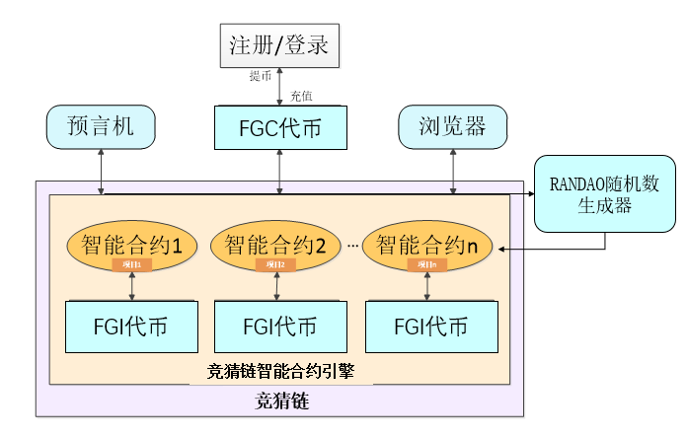

Picture 1. Fair guessing chain – Fair Guess Service Platform（FGSP）

Registration/Login

Oracle FGC Token Coin Browser

Smart Contract 1 Smart Contract 2 Smart Contract n

RANDAO Random Number Generator

FGI Token Coin

Fair guessing chain Smart Contract Engine

Smart Chain

### Fair guessing chain Concept

Fair guessing chain aims to create a fair, safe and highly entertaining guess service platform, always upholding the full process of TCOC operating philosophy of public transparent, concise operation, code open, community autonomy.

Transparent：Focus on the whole process of product operation, to ensure that the process is open and transparent, fair and impartial no black box operation may, unlike the existing longest chain voting mechanism, the Guess is the most advanced based on public data generation of random number of participatory decision making algorithm, to ensure openness, fairness and transparency.

Concise: The entire platform of fair guessing chain can be a tool of modular tools, and integrated a lot of open source modules, so that all customers regardless of their participation in the Guess project, or their own custom and release the Guess project, the whole process concise and smooth, do not waste time and energy.

Open: Fair guessing chain platform will be the upper application of the functional components required to encapsulate, developers to achieve the corresponding functions, just register as a developer can get access to the interface (provide RESTFUL , Websocket RPC access interface, data analysis, deployment of intelligent contracts, etc.). The platform provides the visual management tools needed by the developer for operational maintenance. Developers can through the API&SDK personalized Guess task customization and release, open each vertical field Guess market.

Community：Fair guessing chain is designed to create a fair Guess service platform for the clients who like to guess and become an exchange platform for enthusiasts and the task of publishing companies such as block chain technology enthusiast, traditional lottery, lottery, betting. To create a center for IM tools, customers to build their own community, but also through the community to form their own guessing friends circle, the release of personalized Guess task, set Guess task release, Guess project participation, online communication, online voting in one of the community platforms.

### Double-chain System of Fair guessing chain

Double-chain system is a very good way to realize fast transaction, which takes into account the central feature of block chain and the optimal efficiency. Fair guessing chain plan to create a dual-chain mechanism (public chain + proprietary chain), in which the public chain as the basis of the election mechanism of the accounting person, using the open nature of the public chain, so that more people participate in the private chain of registration nodes and bookkeeping, and give certain returns. The proprietary chain is based on the open source technology of the ether square and also creates a relatively independent block chain environment on the basis of the joint public chain. In this environment, customers can deploy proprietary smart contracts to build exclusive autonomous communities. Relatively independent environment can help customers on the business of relatively closed Guess task release, but also can apply for the public chain registration node to obtain distributed accounting rights. The double chain system helps the Fair Guess Service Platform (FGSP) realize the center of interest, bookkeeping and transaction, while supporting the flow of assets on the chain of instantaneous and low fees, and improving the transaction efficiency.

Fair guessing chain selected the Ethereum as a fair Guess service platform of the underlying technology.

The reasons are as follows:

1. Ethernet Square provides a complete programming language and programming interface;

2. The erc20 ERC721 of the ether square is a token. The etheric square can easily issue tokens, making it easy to establish an economic model based on tokens. Almost all wallets now support ERC20 tokens. The Ethernet cat, lights dog and so on, are used in the use of ERC721 tokens substitution token of the real object.

3. Code Open source.

All smart contract codes are located on the public chain of the etheric square, and anyone can view, understand and verify them at will.

4. The tools of the ether square are complete. The ether square currently has the most complete set of tools in the public chain circle.

User training, you can master.

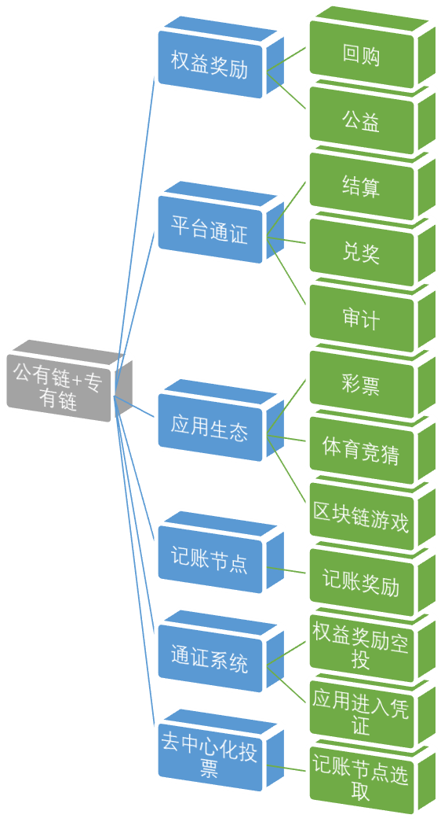

Picture 2 Double Chain Technology Framework

Public Blockchains + Proprietary Blockchains

Equity Award: Repurchase / Public Benefits

Platform Certification: Settlement /Claim a Prize /Audit

Application Ecology: Lottery/Sports Guess/Blockchain Games

Billing Node: Bookkeeping Reward

Token System: Equity Reward Airdrop /Application Entry Voucher

Decentralized Voting: Accounting Node Selection

## The Significance of the Fair guessing chain Platform

### Social Significance of the Fair guessing chain

The number of guess platform for the game rules and data sources are vague. Guessing the winning algorithm and guessing process is not transparent both difficult to get the data and difficult to ensure the authenticity of the data obtained, so it is difficult to ensure that Guess platform fair and impartial. In addition, the traditional Guess platform to participate in the process requires users to first recharge to the channel or according to the user's credit to open a certain amount of credit, and then the channel in their own account system for the user accounting. The ability of the channel to keep the assets and the risk of the operation supervision determine the security of the user's assets, which has a certain risk to the users.

Fair guessing chain can effectively protect the participants of the Guess information, the whole guessing process is open and transparent, tamper-proof against the shady. Guessing chain can reshape the trust system of the guessing industry, improve the contractual spirit of the participants and provide a good entertainment environment. By deploying the intelligent contract on the block chain, the atomic nature of the transaction can be realized, the mortgage token before the transaction and the payment tokens after the transaction are stored in the user's own block link address. The entire transaction process users do not have to transfer to the channel, the channel does not trust the user under a single fund, asset loss or channel run risk of zero, even if the channel closed, will not have any impact on users. Digital chips and other data block encryption function, can effectively protect all the guessing entertainment users of the information security, especially to meet high-end VIP customer privacy requirements. In addition, the default smart contract allows long-term betting, and once the long-term bets are triggered, the smart contract will execute or provide evidence directly.

### Economic Benefit of the Blockchain Guess

Using of the digital currency based on the block chain can exceed the traditional lottery games, such as the disadvantages of geographical limitations, can be anywhere from any place any time to complete the lottery and other guessing products purchase and honour, even in the absence of banking infrastructure, as long as there is a network can be carried out. This will extend the coverage of the traditional Guess to a great extent and increase the potential stock of the Guess market.

Each Guess is based on the Fair guessing chain Platform of an intelligent contract, through the platform based on the ether, guessing chain technology will make guessing more efficient and convenient, in the fundamental completion of the guessing industry replacement. The global guessing entertainment platform based on block chain technology is not only the innovative block chain entertainment platform, but also accepts the payment of digital currency such as BTC and ETH, and will bring more than 20 million of the world's digital currency players into the Guess market.

### Application of New Technologies such as AI and Big Data

The Fair guessing chain will introduce large data technology to improve the service quality and efficiency of the guessing entertainment industry. Large data can provide a comprehensive and accurate probability analysis. Fair guessing chain customers can be at any time according to the Fair guessing chain to provide large data services, dynamic adjustment of odds and betting amount, and to ensure that their interests maximize. On the other hand, the Fair guessing chain will also be on the Access platform user data analysis, such as based on user, custom and preference, personalized recommendation products, etc., can help optimize User Service strategy; On this basis, the Fair guessing chain can provide microfinance, credit cards, insurance and other digital financial services, so as to better provide services to users.

Fair guessing chain will also use artificial intelligence technology to improve the quality of the Guess entertainment service level, combined with large data and machine learning platform to improve the efficiency of guessing entertainment and high-quality development. Artificial intelligence application in customer service can deeply analyze the user's habits and try to figure out the user's intention to more personalized customer service, save the platform of human costs.

# Chapter 3

# Introduction of Function Module



## Fair guessing chain Basic Technical Framework

Guessing chain based on the bottom of the block chain Intelligent contract mechanism to establish a basic technical framework, a total of four layers: the public chain bottom token, large data and AI layer, smart contract layer and service expansion layer. The first layer is the public chain of the bottom token, which is used to issue the withdrawal of the encrypted currency FGE, as a certificate of equity and platform-approved trading methods; The second layer is large data and AI layer, large data base for the top of the entertainment activities of the application provides a variety of data support, AI layer in which the AI technology can also provide a series of auxiliary functions, including intelligent betting, intelligent identification and so on. The third layer is the Intelligent contract layer (smart Contract), which is based on the public chain of guessing intelligent contract layer, you can customize a variety of entertainment Guess scene of the intelligent contract template, in addition to provide the packaging of Intelligent contract API, as a toolkit to provide customers, to facilitate the custom development Guess project, Open the vertical field Guess market; the fourth floor is the service development layer, Fair guessing chain platform (FGSP) will assist customers to graft their own distributed applications, customers can build their own private chain on the basis of the public chain, to create closed and specific scale of the exclusive entertainment Guess community, using the platform to provide the center of the IM tool Set Guess entertainment, Intimate social integration. Fair guessing chain Platform will provide a series of low-level data access and interface based on multiple languages, providing a series of services including registration, transaction record, ownership certificate, data query engine and so on.

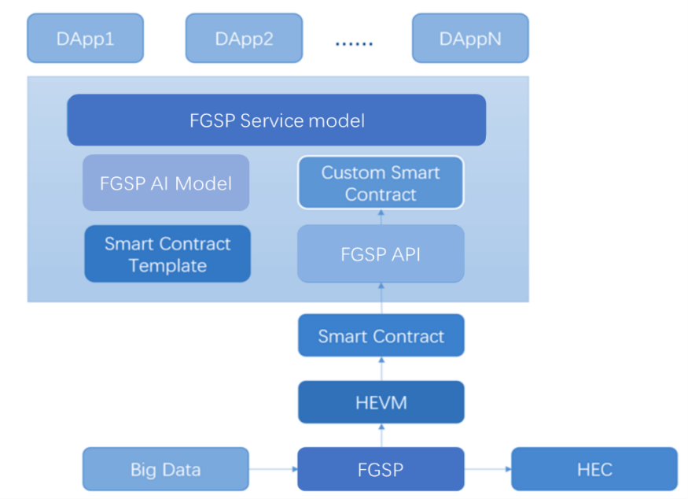

Picture3. Fair guessing chain Basic Frame Diagram

## Key Techniques of Fair guessing chain

The Fair guessing chain allows developers to create any scalable, standardized, and easily developed collaborative applications. Fair guessing chain will be a global common block chain. Based on the bottom of the public chain, a new type of software application is formed, and is a true decentralized betting application embedded in the program running Trust logic chain. At the bottom, the Fair guessing chain is a multi-level, based on the open source Technology agreement of each function module fully integrated packaging package, as a whole, it is used for the creation and deployment of distributed guessing entertainment application of the integrated platform, the realization of the public chain and Peer-to-peer network docking. At the same time, the Fair guessing chain also has a complete intelligent contract engine, users can automatically generate templates through graphical interface and deployment, greatly reduce the user's learning curve and the development of intelligent contract burden, thus greatly reducing the use of guessing chain of the use of the threshold, and has a complete set of tools, can expand the application of intelligent contract scenarios.

Fair guessing chain to be issued based on the Ethernet square intelligent contract, in line with the ERC20 token (Ethernet square token: Allow wallets, exchanges and other intelligent contracts in a common way to butt various tokens) Standard double token FGE, to develop the intelligent contract engine, is a certificate of equity, will be on the line of large mainstream exchange trading flow. In addition, a ERC20-compliant token FGC (Fair guessing Coin) is issued based on the Ethernet square intelligent contract. FGC is the Fair guessing chain in the official online run by the intelligent contract generated. Fair guessing chain users to publish in the Fair guessing chain on any one project to make predictions, only and must use FGC to operate: Launch project, Guess project and Validation project.

The random number generation algorithm of guessing chain is a participatory decision algorithm based on Randao idea, which takes participants as random sources. Based on the strong robustness and centrality of the Block chain network, a transparent Randao algorithm is calculated based on the random number provided by the participant, thus obtaining the absolute random number based on the participant random source, and is safe and reliable. and to all kinds of guessing games to provide absolute random factors, through the random factors to get a variety of play needs of the transparent random number, to ensure the absolute fairness of lottery and transparency.

The decentration of the fair guessing chain IM tool can help customers point to point of communication, with real-time, efficient, secretive characteristics. Customers can use this tool to build their own social circle, as a friend to participate in the Guess task, publishing offline party information and other private social tools. A proprietary chain of erection agencies can also maintain their own community network through the IM tool.

In addition to the block chain of the underlying technology support, Fair guessing chain will also introduce new High-tech technology, including large data and AI. Fair guessing chain will be based on block chain and large data, combined with artificial intelligence AI development depth of application, including but not limited to Oracle prophecy, intelligent Customer service, intelligent assistant, Guess Entertainment products personalized recommendations, etc., so that the guessing chain more intelligent, safer, more effective service gaming entertainment market and global users.

## Platform Participants

Fair guessing chain Public Guess service Platform (FGSP) Participants according to the Intelligent Contract Process function classification, can be divided into three kinds: Project sponsors, project Guess Party and Project Verifier. The project exists in the form of an intelligent contract. The life cycle of the contract is as follows: When a Guess party publishes an intelligent contract, in which the smart contract rules the form of guessing, lottery, etc., in the full chain platform to accept bets, you can also choose to publish in the private chain platform, when the preset lottery conditions to meet the lottery and automatically realize value transfer, if not the jackpot is stream.



Picture 4. Lottery Frame Diagram

Contract Release

Accept Bid

Is the preset bid opening condition satisfied or not?

If not: Failure of Bid

If satisfied: Open bids and realize value transfer

Contract destruction, offline archiving

### Sponsor of the Project

The project sponsor can be the public chain user of the guessing chain, or it can be the organization and company of the private chain platform built by the service interface provided by the guessing chain. Project Initiator on the Fair guessing chain platform to enter the release page, fill in the project details, amount and lottery conditions. Fair guessing chain platform in the network platform will provide common fixed play contract template, users can choose to use the Smart contract template, can also use the API and other software development tools to develop new Guess project. Smart contract template to be completed after verification, the system will automatically generate intelligent contract code, and deployed to the Fair guessing chain, the following figure:



Picture 5. Release Frame Diagram of Guess Program

Login project release page

Select a contract template

Fill in the project details and set the conditions

Test, security verification

Release project

Blockchain Browser Verification

Some smart contract templates are preset, and the platform provides custom template functionality if the project initiator cannot find a shared template. When a successful contract is issued, the project initiator obtains the contract address and, of course, can check the status of the contract through a system search or a list of items.

### Guess Part of the Project

Project Guess side for the guessing chain customers, can also be set up a private chain of institutional customers. In addition, the platform provides to the center of IM tools, the project initiator in the release of a Guess task, through IM tools to invite their friends, companions to participate in the Guess project, so these people are also one of the project Guess party. At the same time, the platform will give a certain token of token reward. Project Guess party can be published through the main chain of the Guess project list or search function directly search the project name or intelligent contract address, choose their own interest in the project to participate.



Picture 6. Betting Frame Diagram of Guess Program

Read project details

Fill in the bid amount

Participate in bidding

Blockchain Browser Verification

### 项目验证方Project Verifier

Based on the fair guessing chain principles of fairness, open, fair and transparent, the guess results have objections to the participants can be provided by the system blockchain browser, with the project's contract address to view the contract content, the Guess results are confirmed, and invite the authority of the relevant qualification of the third party to conduct fair and impartial verification.

## The Public Service System of the Fair guessing chain

As a fair Guess service platform, the purpose of the fair guessing chain is to use blockchain technology for project sponsors, project guess party, project verifier to provide a safe, reliable, convenient and intimate full-service content.

### Network Platform Service

Fair guessing chain headquarters will be located in Manila, the Philippines, focusing on the global online guess market, and actively exploring other forms of entertainment, to create an open, three-dimensional set of traditional lottery, internet lottery, sports Guess, personality Guess in one of the fair service platform. In addition to building the underlying SDK based on the public chain, customized client applications will be provided, including but not limited to PC-side, WAP station, APP (IOS & Android), PAD end, H5 applet, etc.

### The Access of Third Party Access

Fair guessing chain will provide intelligent contract templates and frameworks, application components, as well as customized APIs and SDK to provide entertainment Guess services to third party organizations or individuals, reduce the online development of entertainment guess threshold, open the exclusive Community network access channels.

### 竞猜项目综合管理 General management of guess program

Fair guessing chain Fair Guess Service Platform (FGSP) will provide for online Guess project set up an integrated management system, will provide in line with the laws and regulations of the guess Project release, lottery, withdrawal full flow management services, including user profiles, commission settings, financial and other functions.

### Cooperation of Online and Offline

In addition to providing online guess entertainment services, the same will be the world's other entertainment companies open the public chain interface, so that the offline trading mode of digitization, and gradually build Guess customers, guess organizations and other entertainment project fans online services to provide a platform.

### Asset Exchange

Many users hold other mainstream digital assets (BTC，ETH, etc.). Fair guessing chain on this basis to build a trans-chain wallet, can accept the mainstream assets into and storage, and platform circulation of the FGE currency free convertibility, even with its mainstream digital assets as a chip directly involved in the Guess. At the same time, the double TOKEN mechanism of the Fair guessing chain also issues FGC tokens and legal currency anchor, to ensure that the betting and holding of chips to achieve asset value, to avoid fluctuations in the currency caused by the instability of values.

## System Module

The architecture of this system is based on the Ethernet square technology: EVM mechanism and intelligent contract mechanism. To facilitate EVM debugging and contract security verification, the Zeppelin library will be used. The system is mainly composed of the following parts

### Management System of Fair guessing chain Account

#### Register Login Module and Trusted Authentication

The main function of registering the login module is to assign the wallet address to each user who participates in the quiz activity. The purpose of this function is to provide users with a fool-like service, get involved in the quiz activity ID. The entire login process includes:

* Assign a Public/Private Key Pair to Each Registered User

Assign a public/private key pair to each registered user as the unique ID of the user identity. The public key is used to send and receive the FGC tokens of the Guess platform. The private key has two options:

（1）Private key stored on server side

The advantage of this is that the private key can be retrieved by the server when the user forgets the private key. The price to pay for this is that the server is centralized, the information vulnerable to attack, and easy to be deliberately leaked.

（2）The private key is saved and managed by the user himself, and the server does not save the copy

The advantage is high security. The potential risk is that if the user is poorly managed and loses the private key, the corresponding digital assets are lost and cannot be recovered.

* Each user registers the process to provide the mnemonic word. The key is to restore the user's private key through mnemonic words

Fair guessing chain user authentication on the chain, with token address as the user's unique identity and asset identification, and based on artificial intelligence face recognition detection technology to ensure the authenticity and consistency between digital identity and real person. The authentication of user authentication and asset transfer without intermediary participation is realized under the control of intelligent contract, and the authentication of user identity in whole guess life cycle is realized.

#### Decentralized Account Management

Account is the user's passport in the Internet world and is the identity of the user. Traditional user identity stored in the center of the Web server, fair guessing chain account management system to use the central authentication system, the user's identity information and credentials do not belong to any body all, really fully in the user's own hands To the centralized account system, the user's identity information and authentication process are carried out in the Blockchain network, which is dispersed in the whole global equivalent blockchain node, and there is no authoritative node, which guarantees the security of the system. As an impartial "centralized service provider", intelligent contracts instead of the traditional central service provider, it realizes the open and fair "autonomy" to the central organization, and avoids the central account management system, and the risk of the user information being leaked and tampered with, if the server is attacked, or the interests drive, politics and other man-made reasons.

### Management System of Guess Data

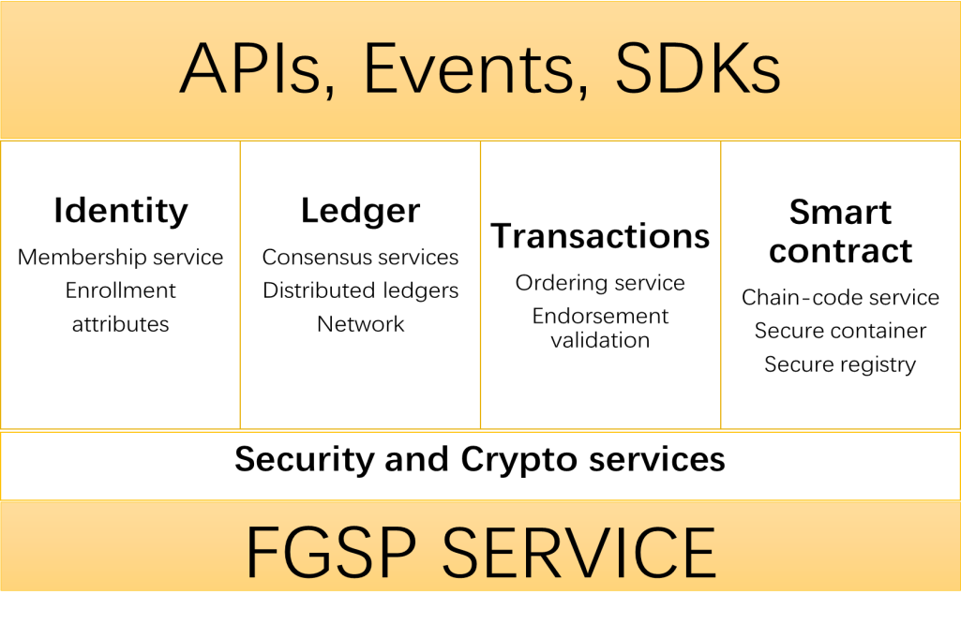

Picture 7. Technical Model of Guess Data Management System

The set up the blockchain guess system of the fair guessing chain, users participate in the guess project, which can immediately in the blockchain network to find their own participation in the project list, guess records and processes stored in the blockchain network, can not be tampered with and denied. Fair guessing chain official platform to provide data query function on the chain, users can through the platform or direct chain transactions, to ensure the whole guess process of fairness and security.

On the claim a prize settlement system, the fair guessing chain will be the final Guess records linked to other systems of the distributed ledger, including user identity information and link Oracle (and based on participatory decision-making (participatory Decision making) of the random number generator, fair guessing chain will be based on intelligent contract automatic settlement bonus tokens after receiving the guess results, not subject to any central institutions or third-party institutions control, immediate bonus token distributed to the blockchain network users on the identity of the address, to ensure the redemption process of absolute openness, fairness and transparency.

### Fair guessing chain Intelligent Contract Engine

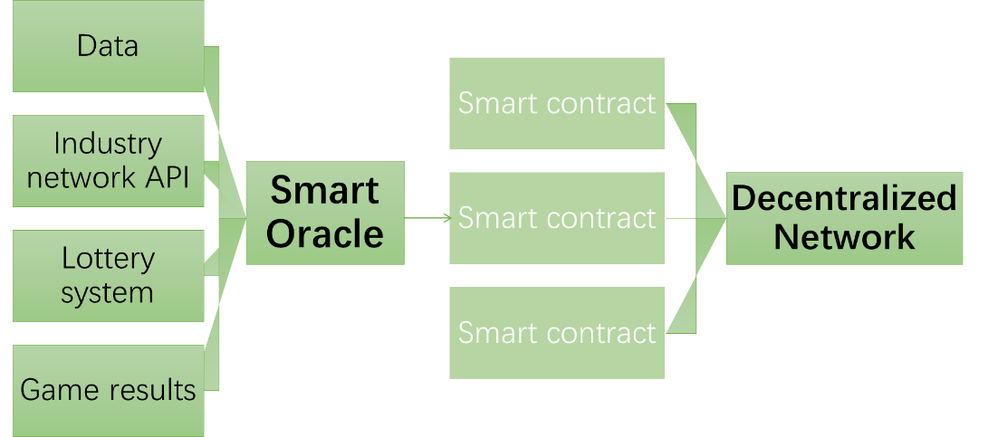

Picture 8. Fair guessing chain Intelligent Contract Engine

Fair guessing chain user needs are diverse, for the winner of the lottery logic, some users have very definite winning conditions, and some users are randomly selected. For the winning conditions, some users are set to be fixed, for example, hiring contracts for the requirements of the graduation institutions, and relatively, some users of the winning conditions may be dependent on the changes in external conditions, such as the recruitment of certain posts, if it is female, then 40 years old, if it is male, then under 50 years old. The Fair guessing chain platform provides some of the most common logic for smart contract templates, and the integration of intelligent contract automation generation engine technology, users can be graphical interface to automatically generate templates and deployment, greatly reduce the user's learning curve and the development of intelligent contract burden, thus greatly reducing the use of fair guessing chain of the use of the threshold. For those business logics without presets, users can choose to develop themselves and provide guidance from the platform. Or you can have a platform for direct customization development.

### Random Number Generation System of Fair guessing chain

The generation of absolute random numbers is the key technology to guarantee the fair and impartial results of the Guess, and it can be regarded as the core competence of the service provider. The industry provides a lot of pseudo random number of schemes, and the original solutions because all are based on the central solution, theoretically can be through a variety of ways to break or modify, especially in a variety of online Guess platform, random number generation of security and reliability has been questioned.

The fair guessing chain designs a set of random number generators based on the Randao idea to take participants as random sources to ensure the fairness of the algorithm. Among them, Randao algorithm by the ether Founder V God as the current most fair and random random number generation algorithm, fair guessing chain algorithm is to Randao random number generation algorithm simplification and promotion, and further avoid the last one betting compared to other sequential winning probability slightly higher.

The Randao protocol layer encapsulates intelligent contracts on one or more blockchains into random numbers to form algorithms that correspond to different business requirements. So it can guarantee the diversity of the random number service, and make the protocol cover a wide range of applications to meet more application requirements. With the advance and development of the blockchain platform, Randao will encapsulate more random number generation mode with market demand, in order to randao the standard random number service on the blockchain, the random number service will undergo rigorous testing and safety audit to ensure the quality of the service on-line.

The random number generation algorithm of fair guessing chain has 2 characteristics: duplicate hash (Repeat hashing) and contributor contribution (Participator contribution). A duplicate hash is a data source that is hashed multiple times, and the result output of the last hash is the input to the next hash operation. Here is the schematic:

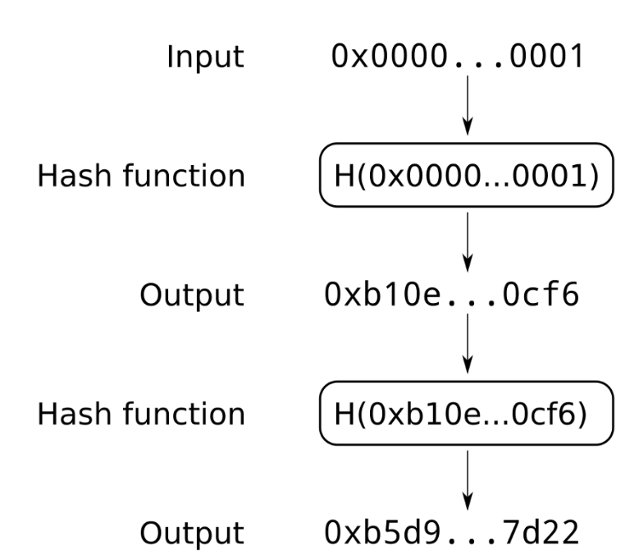

Contributor contribution refers to the system can obtain a final value from the contribution of multiple participants, the contribution of the participants to different values will lead to the difference in the final value. At the same time, any participant is at the same starting point as the rest of the participants in the final value formation. A valuable feature of the contributor's contribution is that as long as one of the participants is trustworthy, the final value is guaranteed to be trustworthy. There is only one case where the results are not credible: all participants conspire.

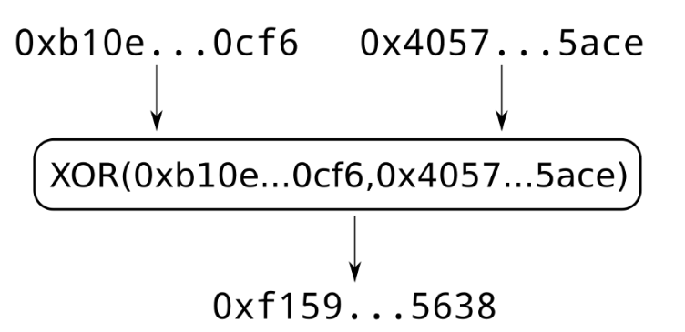

The specific random number generation process is as follows:：

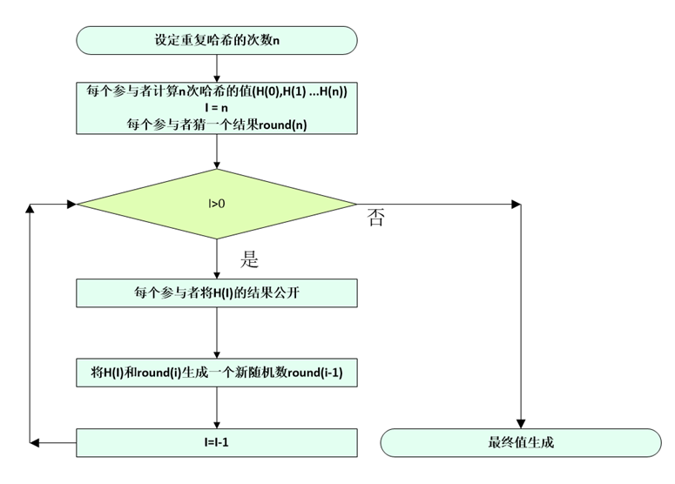

Picture 9. The Randao Model of Participatory Random Number Generation Algorithm

Sets the number of repeated Hash n

Value (H(0),H(1)…H(n)) for each participant to compute N-time Hash

Each participant guesses a result

Yes No

Each participant exposes the results of H(I)

Generate a new random number round(i-1) with H(I) and round(i)

Get the final value

### Decentralized Information Communication Tool

In order to enlarge the participation of the Fair guessing chain platform, we set up a centralized information communication tool based on Point-to-Point protocol in the initial stage, so that we can publish the project information through this information exchange tool for the Fair guessing chain customers. The centralized communication tool based on Point-to-Point protocol can ensure information security, prevent leakage and prevent detection, and because of its centralized storage mode, the information does not need to be temporarily stored by the central server, thus preventing the data backup of the centralized storage organization. The information transmitted in the communication tool is end-to-end encrypted, which makes the user more intimate and pure than the Exchange transaction and personal communication of the project.

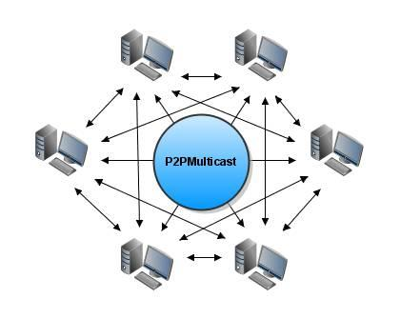

Picture 10. P2P Instant Messaging Model

### Other Auxiliary Tools of Fair guessing chain

#### Blockchain Browser

Fair guessing chain is based on the Ethernet square technology. For each project activity, code that contains the business logic of the activity is deployed on the chain in a smart contract manner. All the smart contract codes on the ether are transparent and can be viewed through the Blockchain browser tool

* <https://www.etherchain.org/>
* <https://etherscan.io>
* There are lots of similar tools

Fair guessing chain also provides a similar Ethernet square blockchain browser, user-friendly query the corresponding contract code

#### Contract Template Assistant

The Fair guessing chain Presets A number of commonly used project templates to cope with daily high-frequency needs. But there are always some unique needs in the market, and these needs are real. Based on the market-king, user-King belief, given the complexity of the current intelligent contract programming, fair guessing chain will introduce a ranking mechanism, allowing the platform of registered users to propose the need for intelligent contract, by the user regularly vote to generate rankings. The Fair guessing chain platform will develop templates for top-ranked requirements, or provide guidance and security checks. After the actual operation of the market test, the standard template will enter the preset template list for the general User Service.

# Chapter 4 Expansibility



## Oracle

An oracle is a trustworthy entity that introduces information about the state of the external world by signing, allowing a determined intelligent contract to react to an uncertain outside world, such as a World Cup Guess, in which smart contracts need to get results before they can execute the contract. Prophetic machine has the characteristics of tamper-proofing, stable service and auditing, and it can ensure the normal operation of intelligent contract by providing data chain. However, in order to ensure the correctness and reliability of the source data, we propose a mechanism of going to the central prediction machine under the multi point situation. The prophetic machine source data will come from multiple trusted nodes. At the same time, through the token reward mechanism of guess the user selected volunteers to participate in the decision, and when the results of multiple trusted nodes are not at the same time, the blockchain network participants will be the results of multi-party verification, through the multi-point data + multi-point verification method, To ensure the security and reliability of the data of the prediction, and then to ensure the whole Guess system open and transparent.

In addition, the fair guessing chain can also access the Third-party Information Intermediary (Oracle), the results of the project by Oracle to decide. These Oracle provide a series of APIs, the fair guessing chain by invoking these Oracle APIs to determine the project's winning party. Oracle can be centralized, or it can be more centralized.

To inquire the price of MIX2 For example, suppose there is now a third-party system (Oracle) can provide authoritative accurate, tamper-assured, stable, and acceptable audit price query interface, the Prophet first from the millet to obtain the price of Millet mix2, and then to a specific block link to the address of the transfer, And the price information into the transaction notes, so that the smart contract only need to see the specific address of the transaction, you can get the price of millet mix2. Because the blockchain automatically synchronizes the blocks that contain the transactions, the smart contract almost requires access to the local price information. Not only the access efficiency is ensured, but also the price consistency is ensured. In general, the Oracle (third party) pushes the data to the blockchain without the need for a smart contract to pull data from the third party on its own initiative.

In most cases, an Oracle is enough, but in the process of dealing with significant assets, often a prophecy is not guaranteed to be completely reliable, the fair guessing chain set up a number of prophetic machines to provide accurate data interface network, that is, multiple prediction machine model is called the Oracle Network.

## Future Extendibility of the Ethereum Technology

Vitalik, founder of the Ethereum, unveiled the latest developments in its leading fragmentation (Sharding) technology. Fragmentation (sharing) is actually a traditional database technology that divides large databases into smaller, faster, and more manageable parts. In a blockchain network, fragmentation transforms each chunk of a network into a chain of sub blocks (100), which can hold transaction data and eventually form a block on the main chain. In this way, the transaction capacity of each block will be expanded by about 100 times. The launch of the new Ethereum technology has become a big probability event. Fair guessing chain based on the Ethereum technology can enjoy the benefits of its own evolution, greatly enhance their trading capacity and data storage efficiency, further optimize the Fair guessing chain service platform user experience.

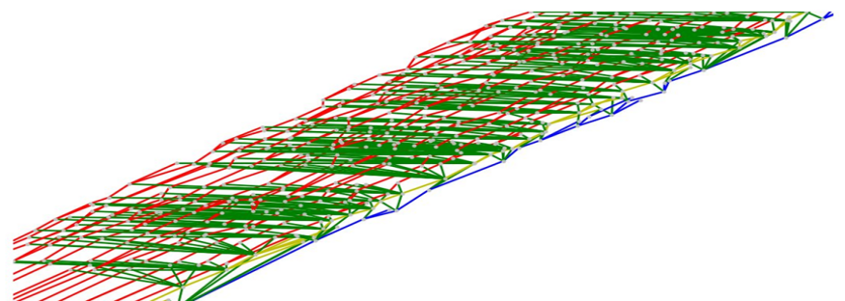

Picture 11. Model of Ethernet Square Fragmentation (sharing) Technology

## Application Context

As the fair guessing chain provides a transparent mechanism, so as to ensure the fairness of the results of each project Guess. The definition of the project is very broad: buying and selling second-hand furniture can be a project, and a leftover date can also be a project. Therefore, the Fair guessing chain can be widely applied to our real life. Here are just a few of the possible applications

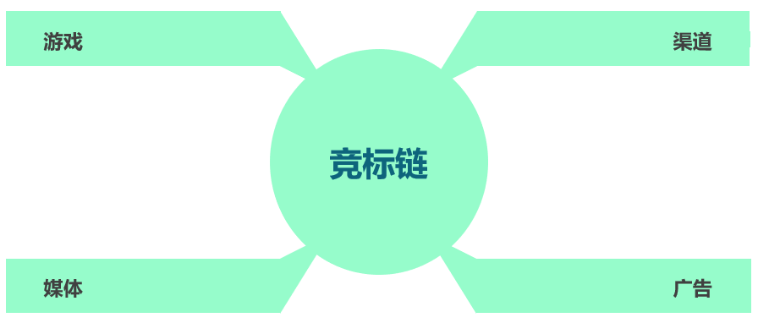

Picture 12. Application Scenarios of Fair guessing chain

Game Channel Bidding Chain Media Advertising

Take the lottery as an example, we firmly believe that the blockchain lottery is the future of the entire lottery industry. The Fair guessing chain platform also supports the complete blockchain Lottery developer Ecology. The intelligent contract blockchain lottery system based on fair guessing chain development, as well as the blockchain lottery application developed by developer Ecological Developer, all support the direct use of FGC to purchase and trade lottery tickets (in response to compliance countries). We will also support the use of mainstream digital currencies as chips and bonuses.

In the case of blockchain games, since the end of November 2017, the advent of the etheric cat, a large number of blockchain game developers compete to imitate, the success of the Ethernet cat and the lower threshold to a certain extent led to the initial blockchain game of homogeneity. At present, the core play of the blockchain game is relatively single, mainly to buy, collection, gambling and other types, whether it is a pet, celebrity, each player's hand virtual props are unique. From a technical point of view, blockchain games and fried coins are similar, and the traditional sense of the game-through the operation and the plot to bring players the game experience is different, blockchain game by getting the rare properties of items to obtain high returns, is actually a speculative process. Based on the Fair guessing chain Platform, the blockchain game will be more interesting. In accordance with ERC721 contract, fair guessing chain of the blockchain game and Guess is also complementary, has a broad prospect for development.

## Cross Chain Purse

We will allow guess party to mainstream digital currency exchange online digital currency as a guess margin, or even the subject matter, which we will develop a cross chain purse. Through the effective operation of the fair guessing chain platform, the trans-chain wallet will become a trading center and personal Digital Asset management platform. Multi-asset support for cross-chain wallet products including BTC, ETH, QBT and other trans-chain of multiple currencies, and thus extended to the digital currency related to social communication, currency trading, payment, quotes, consulting and other functions, and for various types of gaming platforms, game manufacturers to provide exclusive digital chip exchange, And to the standard betting industry and its supporting industries in the basic property rights issue digital assets.

# Chapter 5 Token Mechanism and Issue Program



## Double Token Economic Model of Fair guessing chain

The public-chain system has excellent characteristic of decentralized, but it is not friendly to fast trading (such as guess betting), the Alliance chain has great advantage in efficiency and rate, but it can not reach the complete data transparent supervision.

In view of this, the fair guessing chain will take double Token economic model, one is FGE (Fair guess Equity) Token, belonging to the rights and interests of the certificate, will be on line large-scale mainstream exchange transactions. A stable currency FGC (Fair guess Coin) Token, belongs to the function class voucher, uses in the guess betting.

## FGE Token

* Financial value. Its financial value comes from the improvement of the value of fair guessing chain. Once the use of fair guessing chain platform users increased, the demand for FGE token increased. As demand for FGE token rises, so does the price of FGE trading.
* Use value. Fair guessing chain has a real and clear application of the scene, the platform will be a successful completion of the contract to extract a certain proportion of the handling fee. The holder of FGE token pays a certain amount of FGE monthly to the platform to obtain a certain percentage of the fee reduction.
* Incentive value. In order to stimulate the use of fair guessing chain depth and breadth, the future fair guessing chain Foundation will be successful on the platform to complete the transaction of the user to reward, such as lotto lottery scenarios, each reached 100 yuan in the transaction of Fiat, reward its 1 FGC. It is of great significance for the platform of the Fair guessing chain to be a continuous introduction of the user and the growing self. At the same time, for the long-term holders of FGE and consumer FGE, the platform will be a certain proportion of return fees.
* Developer Eco-rewarding value. The developer ecology is an important part of the fair guessing chain system, and the developer has to submit and freeze a certain number of FGC to the official through the blockchain scene application developed by the open API based on the fair guessing chain system. These APIs not only give developers the opportunity to be used by consumers, to obtain rich development and distribution returns, but also to promote the flow of FGC token and large-scale applications.
* System repurchase destruction. The Fair guessing chain Foundation will take part of the annual earnings FGC token repurchase and destroy.

## FGC Token

FGC is a necessary token to participate in the application of fair guessing chain scene. The advantage of FGC compared to FGE is that it guarantees that FGC will maintain price stability when converting the currency. Users in order to participate in guess and betting items, need to use FGC Token.

FGC token can be exchanged with Fgetoken, and can also be purchased through the OTC market. FGC Token's release is based on proprietary chain networks, which can be traded freely in Peer-to-peer, anonymous, secure, and centralized environments.

At the same time, FGC provides services for the payment of valued assets and issued digital assets and guarantees the value of the digital currency issued.

## Issue Program of FGE Token

FGE token a total of one billion, by fair guessing chain one-time created, its total cap has been set, can not be changed, never additional. FGE token are assigned to different holders according to certain rules and ratios, a certain proportion of the FGE token in the appropriate country to the appropriate population to raise funds for the project of fair guessing chain implementation and operations, including but not limited to the technical research and development of this white paper and iterations, as well as market operations.

## FGE Token Distribution Program

|  |  |  |  |
| --- | --- | --- | --- |
| Amount | Proportion | Distribution Program | Explain |
| 0.5 billion | 50% | Compliance for sale to appropriate population | For fair guessing chain operation, mainly includes development, market, operation, third party organization service, attracting talents and so on. |
| 2.5亿  0.25 billion | 25% | Founding Team  Development team  Consultant Team | Reward the relevant team in the guessing chain construction, development process to make efforts and contributions, thanks to their human resources, technology development, community building, consulting and other forms of the project support. Tokens will be locked in the year, cannot be circulated, in the two years after the end of the lock on the monthly linear release. |
| 0.1 billion | 10% | Market Promotion  Commercial distribution | In the search for resource integration, equity replacement, community support and other processes of business distribution, as well as to support the project promotion and platform to improve the communication required, including "drop" and so on. |
| 0.1 billion | 10% | User Incentives | Each of the 100 FGC deals is rewarded with 1 fge. It is of great significance for the platform of the quiz chain to be a continuous introduction of the user and the growing self. |
| 50 million | 5% | Foundation operation | The foundation has long been responsible for the management of the platform in Development, construction and development, as well as the related affairs of open source community projects. This section is used for long-term foundation operations. |

## FGE Token Sales Program

The FGE Token will be sold in strict accordance with the laws and regulations of the world and in the appropriate manner for the right people. FGE token A constant distribution of 1 billion, of which 50% is 500 million for external sale.

|  |  |  |  |
| --- | --- | --- | --- |
|  | Cornerstone phase | Private placement phase | Public phase |
| FGE Token |  |  |  |
| Time |  |  |  |
| ETH |  |  |  |

# Chapter 6 Fair guessing chain Core Founding Team and Consultants



## Fair guessing chain Core Founding Team

Big data technology expert, Internet financial insurance product specialist

With over 20 years of experience in the information industry and 15 years of experience in the financial and insurance industry

Working experience:

-- Equifax senior system analyst-one of the three major U.S. credit centers

--served as a technical or managerial position in Canada Life Co.,, Royal Bank of Canada, property and casualty application software company, HP's Insurance Systems Development subsidiary, AIA and other financial and insurance companies.

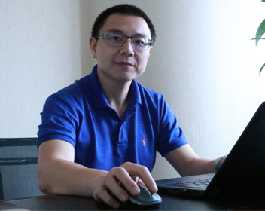

Leon Liu

Doctor of York University of Canada, IBM Senior expert, database technology expert

20 years experience in software product development

Working experience: Work in the IBM Toronto Laboratory Since 2000, currently serving as a senior advisor; establish the Internet payment website Aibao in 2004, as CTO; make speeches at IBM IOD and other large conferences on database-related technology

The author for: DB2 UDB V8 and WebSphere V5 Performance Tuning and Operation Guide

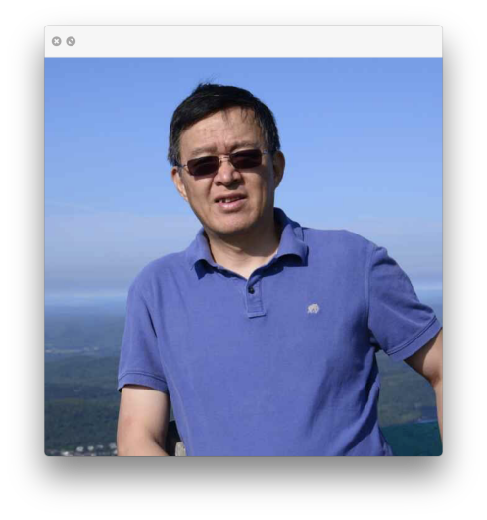

Peter Z. He

Graduated from actuarial and statistical engineering, University of Toronto, Canada, honours degree in Bachelor of Science

Work in a quantified hedge fund platform for a global top 500 insurer

IT+ actuarial trans-border expert, with 10 experience in the insurance industry Working experience: be responsible for the quantitative hedging of insurance fund investment, participate in platform development and investment decision; Engage or lead the team in: Insurance new product development pricing, insurance product reserve calculation, insurance product risk control, reinsurance pricing, group insurance pricing, insurance product underwriting platform development, pension platform development and maintenance

The member of Actuary and MAAA.



Sean Tang



Master of science and technology policy at Cambridge University,

master of graphic communication, National Taiwan Normal University;

Working Experience:

TUTORABC Brand PR Director, DHgate Dunhuang Network senior marketing PR manager;

The presenter for 2016 China Innovation and Entrepreneurship competition, Hong Kong and Macao Games host, 2018 global block chain Broker Summit Moderator, 2018 Peace Development Forum Moderator;

The author for “That year, I’m in Cambridge unveiling Voldemort's Mask”, “Richard Strauss Biography”, “Niberon Ring” and so on;

The columnist of Taiwan World Magazine, “China Times”.



Harry Hsu

## 顾问Consultants



A master's degree from the University of Western Ontario, Canada, with Project management PMP, risk control Crisc and other professional certificates

Former IBM (Toronto) Research and Development Center mainframe compilation optimization development specialist;

Currently work in Ontario Gaming Bureau Network Division approval expert

Tracy Lee

## Early Investor

# Chapter 7 Fair guessing chain Implementation Road Map

December 2017, fair guessing chain Core team was established, market research, integration of key resources, February 2018 completed the quiz chain White Paper version 1.0, establish a technical framework;

March 2018, Start the bottom chain design and module research and development, establish with the Philippines, Cambodia and other countries legal gaming entertainment company partnership;

May 2018, Complete the quiz chain White Paper 2.0 version; complete block chain browser; the first DAPP on the chain;

June 2018, Second, third, fourth DAPP upper chain take the inter tests; multi-center IM tools began to develop; cross-chain wallet and Oracle into the research and development phase;

July 2018, has been on the chain DAPP public testing, based on the one-time creation of FGCE Token, start private placement;

August 2018, completed FGE Token in the mainstream digital currency exchange online, has been on the chain DAPP online, block chain guessing game landed in Hainan;

September 2018, completion of the multi-center IM tool development;

October 2018, Prophet (Oracle) first edition development complete;

January 2019, Mobile End on-line;

March 2019, Intelligent Contract Engine on-line;

May 2019, Trans-chain Wallet online